traffic to my website to ensure healthy business and continued interest for years after launch.



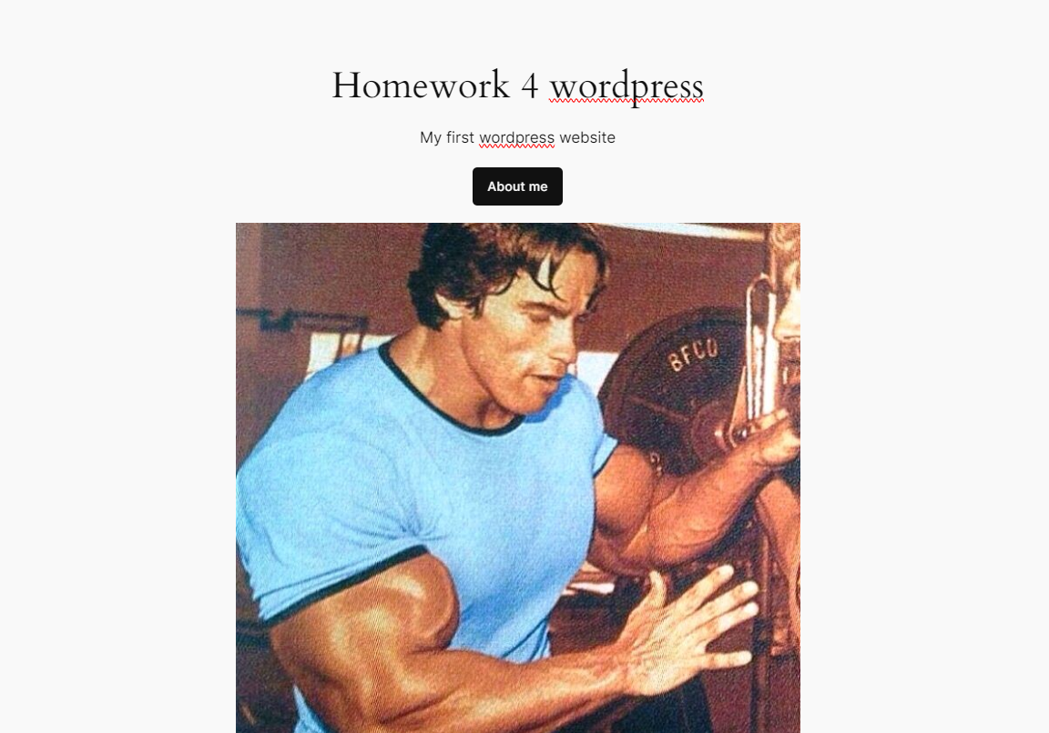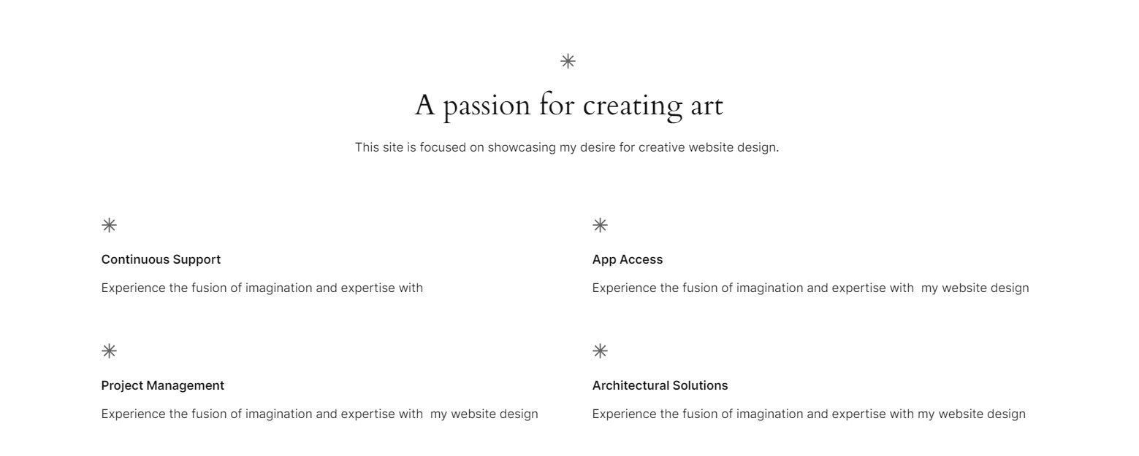

My first website was created by WordPress.

Simple and not complex but utilising visual elements and editing text elements and added a photo to give visual elements to the WordPress website